Agile Documentation for AI-Driven Customer Interaction Dashboard

# 1.Introduction

## 1.1 Project Overview

This project is an AI-driven customer interaction dashboard that provides sentiment analysis, product recommendations, objection handling, and trend predictions. The system uses NLP models, FAISS for similarity searches, and visualization tools to derive insights from customer interactions. Additionally, it integrates real-time speech-to-text conversion using the Vosk library.

## 1.2 Objectives

* Automate customer call analysis.
* Provide sentiment trends and future predictions.
* Offer personalized product recommendations.
* Improve objection handling using AI-driven responses.
* Enable data-driven decision-making through actionable insights.
* Implement real-time speech recognition using Vosk.

# 2. Agile Framework

The project follows the Agile methodology with a milestone-based development approach.

## 2.1 Development Approach

Since this project was developed solo, the workflow was structured around self-managed sprints, prioritization, and iteration. The project was divided into four major milestones, each focusing on a critical aspect of the system. The approach emphasized incremental progress, adaptability, and continuous improvement.

# 3. Milestone Breakdown

## Milestone 1: Environment Setup & Initial Data Collection

Tasks:

* Set up the environment for real-time speech analysis
* Implement initial speech-to-text processing using Vosk for real-time transcription.
* Train and familiarize with LLMs for sentiment analysis.
* Begin collecting initial data from mock sales calls.
* Establish initial benchmarks for data quality and processing speed.
* Develop a Python-based speech recognition system using Vosk and PyAudio to process live audio input.

## Milestone 2: Real-Time Sentiment Analysis

Tasks:

* Implement LLMs (Hugging Face) for analyzing live speech streams.
* Develop algorithms that detect sentiment changes based on tone, language, and context.
* Optimize speech processing latency to enable real-time analysis.
* Conduct multiple iterations to refine sentiment detection accuracy.
* Develop visual dashboards to display real-time sentiment shifts during sales calls.
* Integrate Vosk speech recognition output with sentiment analysis modules for real-time interpretation.

## Milestone 3: Product Recommendation & Objection Handling

Objective:

* Develop a system that recommends products based on CRM data while generating real-time question prompts during calls.

Tasks:

* Integrate data to recommend products based on customer profiles.
* Implement a dynamic question prompt generator that suggests questions or objection-handling techniques based on conversation flow.
* Design and deploy a recommendation engine that adapts based on conversation tone and user history.
* Validate recommendations through iterative testing and feedback loops.
* Improve objection-handling logic by analyzing real-world sales interactions.
* Optimize integration between Vosk-based speech recognition and objection-handling modules.

## Milestone 4: Post-Call Summary & Evaluation

Tasks:

* Deploy the post-call summary generation module.
* Provide automated insights for sales training and improvement.
* Implement a sentiment-based summary report for each sales call.
* Develop an AI-driven insights module that highlights conversation patterns.
* Test with real sales call data and iterate based on sales team feedback.
* Fine-tune speech-to-text accuracy to enhance post-call analytics and summaries.

# 4. Development Workflow

1. Define milestone objectives and break tasks into actionable items.
2. Implement key features and conduct initial tests.
3. Iterate based on testing feedback.
4. Conduct final validation and optimize performance.
5. Maintain documentation for future improvements.
6. Continuously update model parameters based on evolving data.

# 5. Continuous Improvement & Feedback

* Regular testing to refine functionality.
* Self-assessment to optimize AI model performance.
* User testing simulations to validate usability.
* Ongoing integration with newer NLP advancements.
* Periodic reviews to identify areas of enhancement.
* Improve speech recognition efficiency and accuracy with further tuning.

# 6.User Stories

## User Story 1: Data Collection Interface

* **As a** sales representative,
* **I want** the system to collect interaction data (sentiment, transcription, recommendations),
* **So that** I can later analyze the data and gain insights.

## Acceptance Criteria:

* The system collects and stores transcription, sentiment, and product recommendations for each customer interaction.
* The session data is saved in a structured format (JSON).

## User Story 2: Product Recommendations

* **As a** sales representative,
* **I want** the system to recommend products based on customer queries,
* **So that** I can suggest relevant products to the customer during the call.

## Acceptance Criteria:

* The system uses machine learning (Sentence Transformers and FAISS) to match customer queries with product descriptions.
* The system returns the top 3 product recommendations based on the query.

## User Story 3: Objection Handling

* **As a** sales representative,
* **I want** the system to handle customer objections by providing appropriate responses,
* **So that** I can address concerns and move the sales conversation forward.

## Acceptance Criteria:

* The system uses FAISS to search for the most relevant objection and response.
* The system provides the objection and response if a match is found.

## User Story 4: Sentiment Analysis

* **As a** sales representative,
* **I want** the system to analyze customer sentiment during interactions,
* **So that** I can adjust my tone and approach accordingly.

## Acceptance Criteria:

* The system analyzes sentiment using a Hugging Face model and categorizes it as positive, negative, or neutral.
* The sentiment score is saved and displayed in the analytics section.

## User Story 5: Data Visualization

* **As a** sales representative,
* **I want** to visualize sentiment trends and top product recommendations,
* **So that** I can easily interpret the data for future calls.

## Acceptance Criteria:

* The system generates a pie chart for sentiment trends and a bar chart for product recommendations.
* The visualizations are interactive and update in real-time as data is collected.

## User Story 6: Actionable Recommendations

* **As a** sales representative,
* **I want** the system to provide actionable recommendations based on call data,
* **So that** I can improve my sales pitch and customer engagement.

## Acceptance Criteria:

* The system generates actionable recommendations like "Focus on objection handling" and "Highlight top-performing products".
* Recommendations are displayed in a clear, actionable format.

# 7.Technical Documentation

**Libraries Used**

* **Streamlit**: For building the web interface.
* **Pandas**: For data manipulation and analysis.
* **Matplotlib**: For creating visualizations.
* **Scikit-learn**: For predictive modeling (Linear Regression).
* **Sentence Transformers**: For creating embeddings of product descriptions and objections.
* **FAISS**: For fast nearest-neighbor search.
* **Vosk**: For speech recognition.
* **Hugging Face API**: For sentiment analysis and RAG-based response generation.
* **WordCloud**: For visualizing call topics.

# 7.System Architecture

1. **Data Flow**:
   * The system listens to real-time customer calls, collecting interaction data (transcriptions, sentiment analysis, recommendations, and objections).
   * Sentiment analysis is done using Hugging Face API, and product recommendations are generated using FAISS indexing.
   * Data is visualized using Matplotlib and WordCloud.
   * Insights and actionable recommendations are generated for the sales team.
2. **Integration**:
   * Integrates with various machine learning models (RAG, Sentence Transformers) and external APIs (Hugging Face for sentiment analysis).
   * Utilizes FAISS for fast recommendation retrieval and objection handling.

**DIAGRAM:** 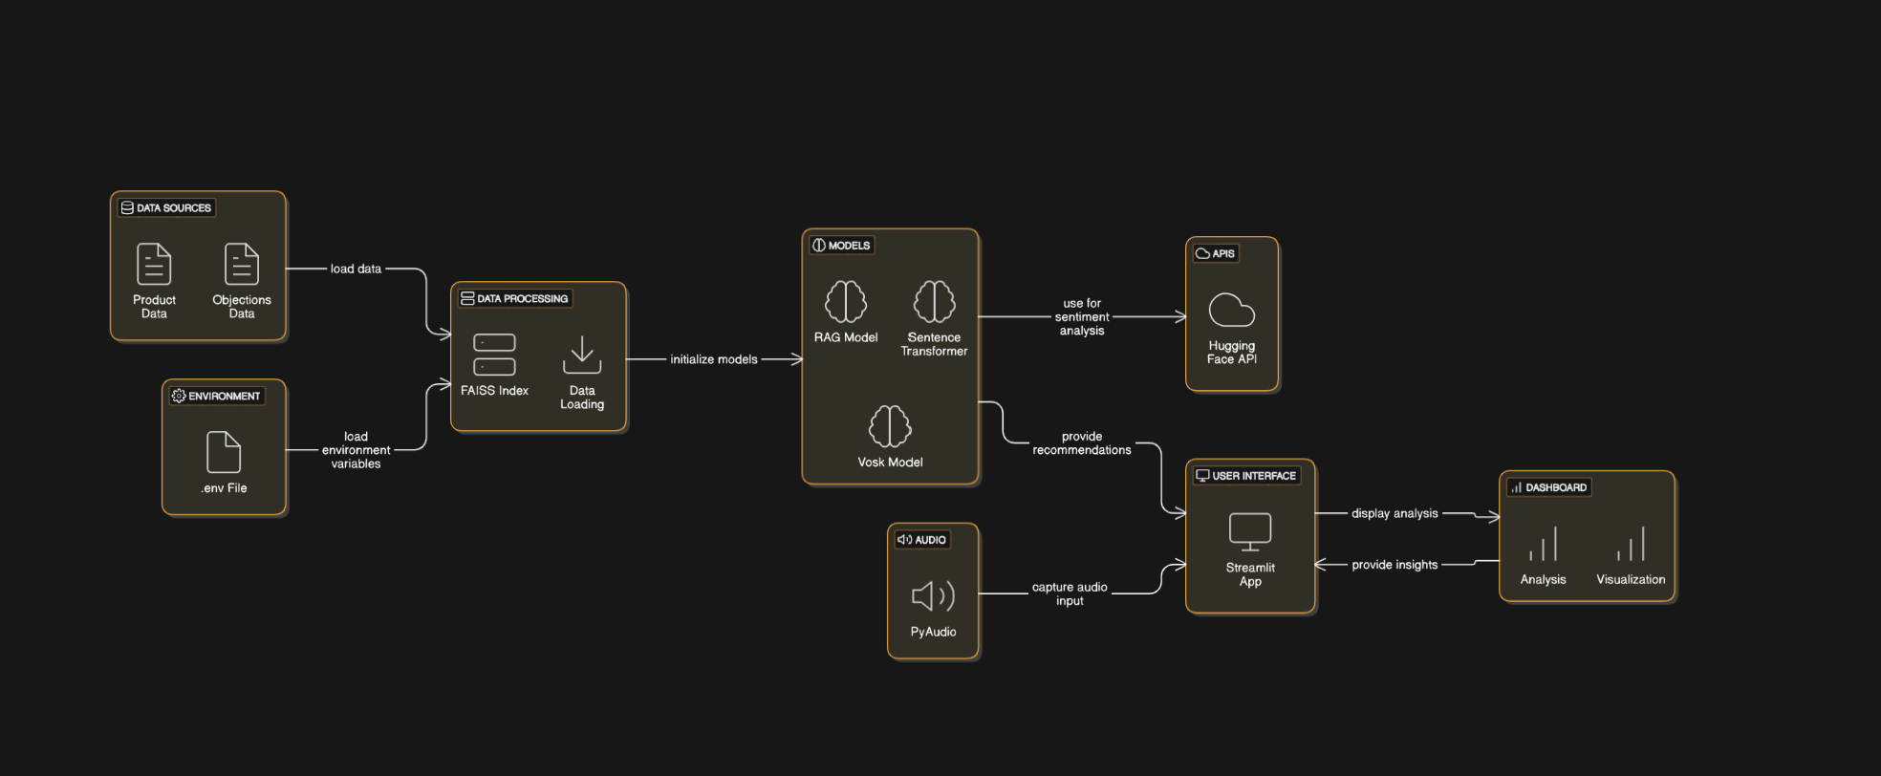

# 8.Backlog

## 8.1. Feature Requests:

* + Add real-time voice transcription and sentiment detection during calls.
  + Enhance product recommendation logic with deeper contextual understanding.
  + Implement automatic objection handling based on customer behavior.

## 8.2. Technical Improvements:

* + Optimize FAISS index for faster query processing.
  + Implement a database to store session data and interactions.
  + Improve data visualization with more interactive and detailed charts.

## 8.3. Bug Fixes:

* + Fix minor UI issues in the Streamlit dashboard.
  + Address any discrepancies in recommendation accuracy.

# 9.Sprint Planning

* **Sprint 1**: Data Collection and Sentiment Analysis
* **Sprint 2**: Product Recommendations and Objection Handling
* **Sprint 3**: Visualization and Predictive Modeling
* **Sprint 4**: Summarization and Actionable Recommendations

# **10. Conclusion**

By following an iterative milestone-based development approach, this project was successfully completed with structured planning, self-managed execution, and continuous improvements. The AI-driven system now provides sales teams with actionable insights, real-time sentiment analysis, and personalized customer interactions. Future enhancements may include deeper CRM integrations, expanded objection-handling techniques, and machine learning-driven conversation trend predictions.